Big Mountain Resort Ticket Price

**Problem Identification Overview**

**Problem**

**How much can Whitefish Mountain Resort (renamed from Big Mountain Resort) increase lift ticket prices for weekdays and weekends in the upcoming season to maintain the service by covering the additional operating costs of $1,540,000 for the new chair lift?**

**Context**

Whitefish Mountain Resort (WMR; renamed from Big Mountain Resort in 2007) is a ski resort in Montana accommodating skiers and riders of all levels and abilities. To provide better service to customers, WMR has recently installed an additional chair lift that would require the extra operating costs of $1,540,000. WMR is desire to know how much they can increase ticket prices and/or how they can cut costs without undermining the ticket price to maintain their profits by covering these additional operating costs.

**Recommendation**

The current ticket price for adults at WMR is $81, which is no difference between weekdays and weekends. Our model suggests that the ticket price can be increased up to $95, which is $14 higher than the current price. Given the mean absolute error of $10.39, I am confident to point out that the ticket price at WMR is underpriced in the market when we consider its top-notch facilities. If we assume that the number of visitors would be 350,000 and each visitor would buy 5 tickets on average, the additional revenue would be $26M, which will cover the operating costs for the newly installed chairlift ($1.54M).

**Data Analysis**

**Data**

* A CSV file that contains 27 features for 330 resorts including WMR. This was provided by the data manager at WMR.
* Population and area data for the US states, which was obtained from a publicly released data table (Wikipedia)

One note is that the ‘Region’ feature is slightly different from the ‘state’ feature in the dataset. While they are the same in most observations, there are several places that a certain state has several regions or different name of region: for example, in California, there are two regions, which are Sierra Nevada and Northern California. In Figure 1, we can check that the number of resorts in Montana, where our target resort is located, ranks at 13th place over entire country. There is no significant difference in the result between region and state.

Figure . Distribution of resorts by Region and State

In order to get insight for the ticket price, we check the distribution of ticket prices over the states (see the left panel of Figure 2). Unlike to other states, in Montana, the average ticket price for weekdays is identical to that for weekends. This may lead us to ask a question as to differentiate the ticket price between weekdays and weekends. In the right panel of Figure 2, we can see that the overall price lies within $25 ~ $125 without considering some outliers. We can see that the ticket price in Montana has small variation over the state.

Figure . Average ticket prices for weekdays and weekends. Left panel: bar plot that compare the average prices. Right panel: box plot that shows variability of the average prices over the states.

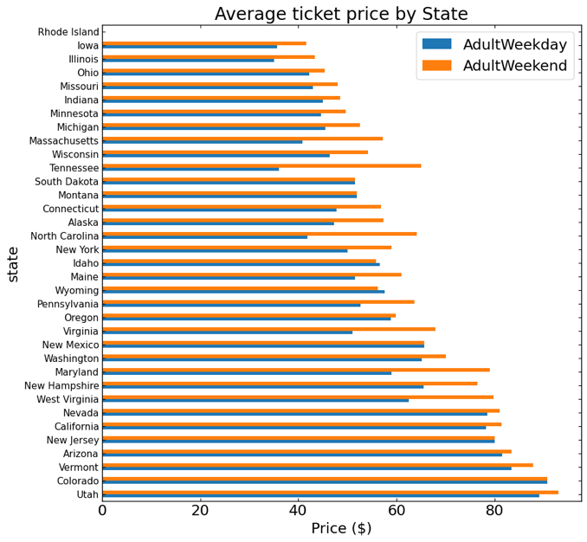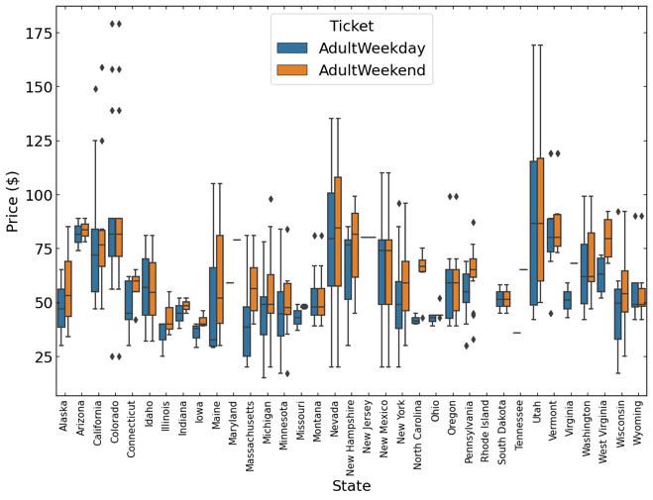

In Figure 3, we can see the distribution of features to help understanding the dataset. The plot is generated after conducting spot check-up and handling the suspicious outliers. While the are some skewed distributions in ‘fastQuads’, ‘fastSixes’, and ‘trams’, overall dataset is well distributed (i.e, no extreme value is shown).

Figure . Distribution of features

**Principle Component Analysis (PCA)**

One challenge is a high number of dimensions per observation. In order to increase the interpretability of data while preserving the maximum amount of information, we apply Principal Component Analysis (PCA) method, which is a statistical technique for reducing the dimensionality of a dataset.

The left plot of Figure 4, shows the cumulative variance ratio explained by PCA components for state/resort summary statistics. It indicates that the first two components take account for over 75% of the variance and the first four for over 95%. We can see the spread of states across the first and second components in the right plot of Figure 4. The values for Vermont and New Hampshire are far off in the second dimension and the values for Colorado and New York are a bit extreme in the first dimension. We check that those states have a notably large density of ski resorts either in terms of state size or population counts.

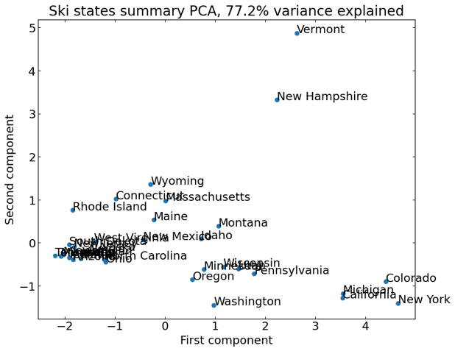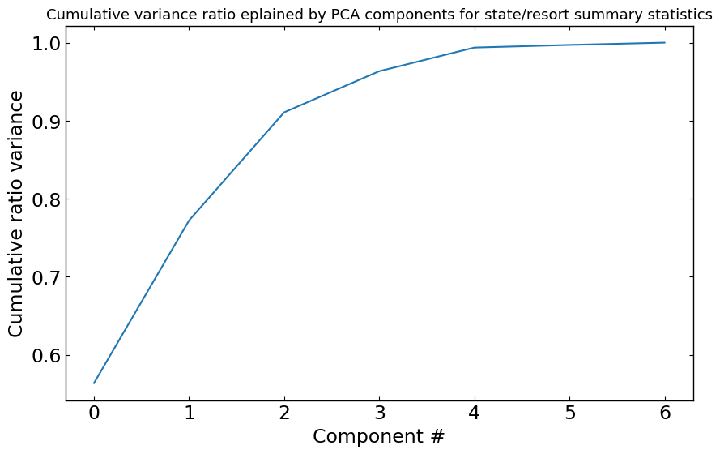

Figure . PCA transformation: Left: Cumulative variance ratio explained by PCA components for state/resort summary statistics, Right: The state distribution over First and second PCA components which cover 77.2 % variance.

**Notable features**

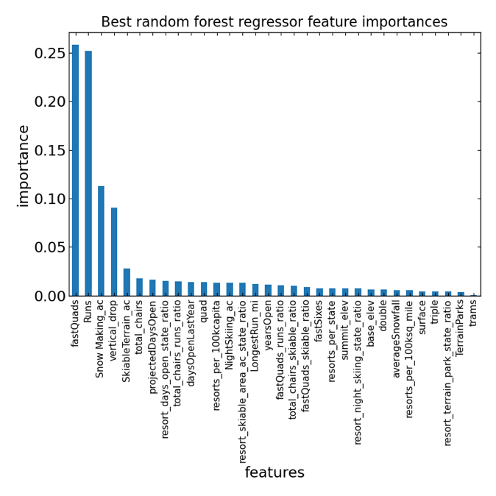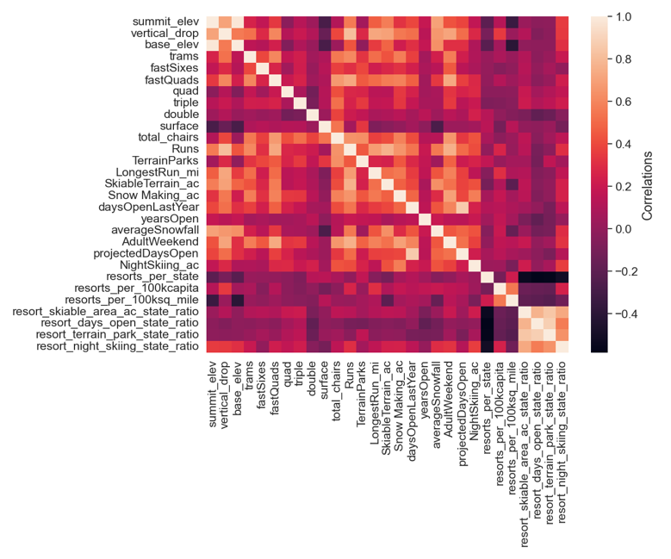

Figure . Left panel: Heatmap that shows the correlation between features. The value along the diagonal line is the unity as the feature is correlated with themselves. Right panel: Bar plot that shows the importance of each feature that is computed by cross-validation of the model through Random Forest Regressor.

As we see in the left panel of Figure 5, there are several interesting points that we can catch from the data.

* Summit and base elevation are highly correlated, which is expected.
* The number of resorts per 100,000 miles2, the ratio of night skiing area between resort and state, and the number of days ratio between resort and state are negatively correlated to the total number of resorts in each state.
* The ratio of night skiing areas is positively correlated to the number of resorts per capita.
* The adult ticket price has a meaningfully positive relationship with the number of fast four-person chairlifts, the count of the total runs on the resort, and the total area covered by snow-making machines.

We establish the model with Random Forest Regressor, which improves the model's predictive accuracy and controls over-fitting by adopting the ensemble learning method. Using the model, we check the cross-validation for the features, which is successful, and evaluate the importance of each feature to determine the ticket price. The result is shown in the right panel of Figure 5. It is well consistent with the correlation heatmap in the left panel of Figure 5, indicating that we should focus on the number of fast four-person chairlifts, count of the total runs on the resort, vertical drop, and the total area covered by snow making machines.

Figure . Histogram that shows the distribution of resorts having the features: Adult ticket price, Vertical drop, the total number of fast four-person chairlifts, and the total number of runs. The vertical red dashed line indicates the position where WMR lies.

The fitted model by Random Forest Regressor suggests that WMR can increase the ticket price up to $95, which is $14 higher than the current price. Since the error of the model is measured to $10.4, I am confident to support the increase in the ticket price. Figure 6 shows the histograms of important features with marking where WMR sits in the distribution. Although the ticket price at WMR is quite high compared to the average value in market share, WMR has very attractive features among other resorts. This possibly supports that the ticket price at WMR is room to be increased.

Figure . Prediction of Ticket Prices as a function of run closed

**Further suggestion**

Our model suggests that the ticket price can be further increased without risk if WMR increases the vertical drop by adding a run to a point 150 feet lower down. Although this requires the installation of additional chairlifts to bring skiers back up, the increase in revenue is measured to $3.5M, which will cover the additional operating cost. Otherwise, the model says closing one run makes no difference, but closing 2 and 3 successively reduces support for ticket price and thus revenue (see Figure 7).

**Conclusion**

After exploring the data for the resorts in the US and applying our model for the ticket to get an insight into WMR’s potential scenarios for increasing revenue, we conclude that

* WMR’s current lift ticket is underpriced and there is a room that increases the ticket price up to $95, which is $14 higher than the current price,
* if we assume that the number of visitors would be 350,000 and each visitor would buy 5 tickets on average, the additional revenue would be $26M, which will cover the operating costs for the newly installed chairlift ($1.54M).
* our best scenario, which was examined by our regression model, is that the ticket price can be further increased without risk if WMR increases the vertical drop by adding a run to a point 150 feet lower down.

**Next step**

There are some deficiencies in the data that limited our modeling to predict the ticket price. It would be useful if we have additional data regarding the ticket prices for junior riders and seasonal tickets, and operating costs for each run. It would also be useful if we could have data as to how many people like to enjoy night skiing/boarding (e.g., ratio of runs between night and day). This would help to differentiate the ticket price for night skiing from that for day skiing.